**Experiment No. 06**

* 1. **Experiment Name**

Cascaded Single Phase and Three Phase H-Bridge Inverter using Simulink

* 1. **Objectives**
* To get familiarize with the Simulink platform and Simulink library
* To develop and study a cascaded single-phase H-bridge inverter using Simulink
* To use the Simulink platform to construct and analyze a cascaded three-phase H-bridge inverter.
  1. **Theory**

**Single phase and three phase H-bridge inverter**

The inverter is a device that converts dc voltage to alternating current voltage and consists of four switches, whereas the half-bridge inverter requires two diodes and two switches connected in parallel. This can be constructed and cascaded into single and three phase inverters as desired.

The primary distinction between a single-phase and three-phase inverter is that a single-phase inverter can generate single-phase power from PV modules. It can also connect to single-phase equipment or the power grid. A three-phase, on the other hand, turns the DC input of solar panels into a three-phase AC output.

* 1. **Apparatus**
* Simulink
  1. **Simulink Block Diagram & Waveform**

**Cascaded Single-Phase H-bridge inverter**

* 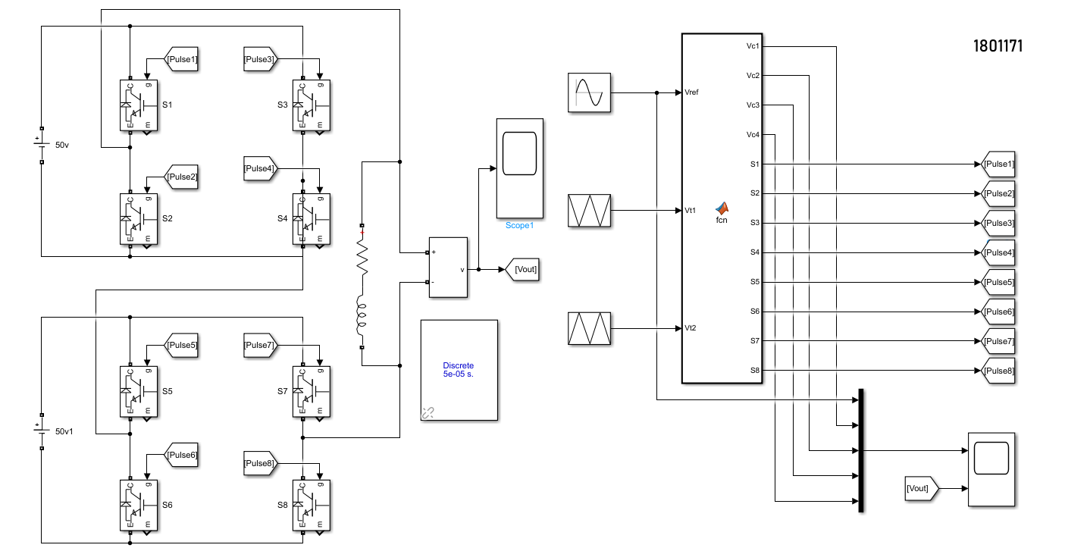**Block diagram**

Fig. 6.1: Block diagram for Cascaded Single-Phase H-bridge inverter

* **Code for MATLAB function**

function [Vc1, Vc2, Vc3, Vc4, S1, S2, S3, S4, S5, S6, S7, S8] = fcn(Vref, Vt1, Vt2)

Vc1 = (Vt1+1)*.25

Vc2 = .5+((Vt1+1)*.25)

Vc3 = (Vt2-1)*.25

Vc4 = -0.5+((Vt2-1)*.25)

if Vref>=0

if Vref>=0 && Vref<=0.5

if Vref>=Vc1

S1=1; S2=0; S3=0; S4=1; S5=1; S6=0; S7=1; S8=0;

else

S1=1; S2=0; S3=1; S4=0; S5=1; S6=0; S7=1; S8=0;

end

else Vref>0.5 && Vref<=1

if Vref>=Vc2

S1=1; S2=0; S3=0; S4=1; S5=1; S6=0; S7=0; S8=1;

else

S1=1; S2=0; S3=0; S4=1; S5=1; S6=0; S7=1; S8=0;

end

end

else

if Vref<0 && Vref>=-0.5

if Vref<=Vc3

S1=0; S2=1; S3=1; S4=0; S5=1; S6=0; S7=1; S8=0;

else

S1=1; S2=0; S3=1; S4=0; S5=1; S6=0; S7=1; S8=0;

end

else Vref<-0.5 && Vref>=-1

if Vref<=Vc4

S1=0; S2=1; S3=1; S4=0; S5=0; S6=1; S7=1; S8=0;

else

S1=0; S2=1; S3=1; S4=0; S5=1; S6=0; S7=1; S8=0;

end

end

end

end

* **Waveform**

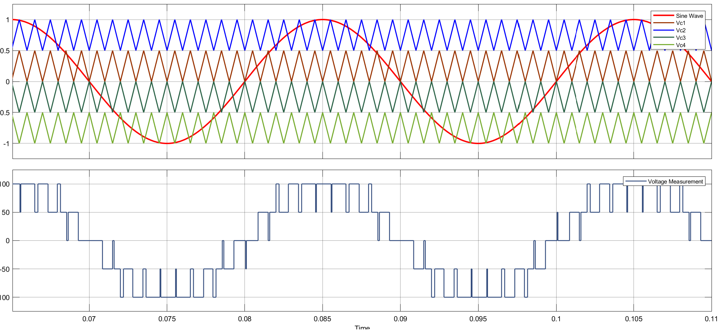

Fig. 6.2: Waveform for Cascaded Single-Phase H-bridge inverter

**Three-phase H bridge inverter**

* **Code for MATLAB function1**

function [Vc1,Vc2,Vc3,Vc4] = fcn(Vc)

Vc1 = (Vc+1)/4;

Vc2=Vc1+0.5;

Vc3= (Vc+1)/(-4);

Vc4=Vc3-0.5;

end

* **Code for MATLAB function2**

function [S1,S2,S3,S4,S5,S6,S7,S8] = fcn(Vref,Vc1,Vc2,Vc3,Vc4)

if Vref >0

if Vref>=0 && Vref<=0.5

if Vref>=Vc1

S1 =1; S2 =0; S3 =0; S4 =1; S5 =1; S6 =0; S7 =1; S8 =0;

else

S1 =1; S2 =0; S3 =1; S4 =0; S5 =1; S6 =0; S7 =1; S8 =0;

end

else

if Vref>=Vc2

S1 =1; S2 =0; S3 =0; S4 =1; S5 =1; S6 =0; S7 =0; S8 =1;

else

S1 =1; S2 =0; S3 =0; S4 =1; S5 =1; S6 =0; S7 =1; S8 =0;

end

end

else

if Vref<=0 && Vref>=-0.5

if Vref<=Vc3

S1 =0; S2 =1; S3 =1; S4 =0; S5 =1; S6 =0; S7 =1; S8 =0;

else

S1 =0; S2 =1; S3 =0; S4 =1; S5 =0; S6 =1; S7 =0; S8 =1;

end

else

if Vref<=Vc4

S1 =0; S2 =1; S3 =1; S4 =0; S5 =0; S6 =1; S7 =1; S8 =0;

else

S1 =0; S2 =1; S3 =1; S4 =0; S5 =1; S6 =0; S7 =1; S8 =0;

end

end

end

end

* 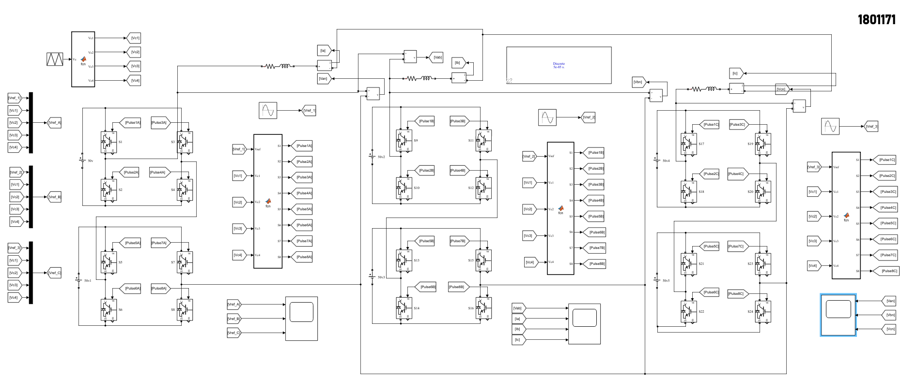**Block diagram**

Fig. 6.3: Block diagram for Cascaded Single-Phase H-bridge inverter

* **Waveform**

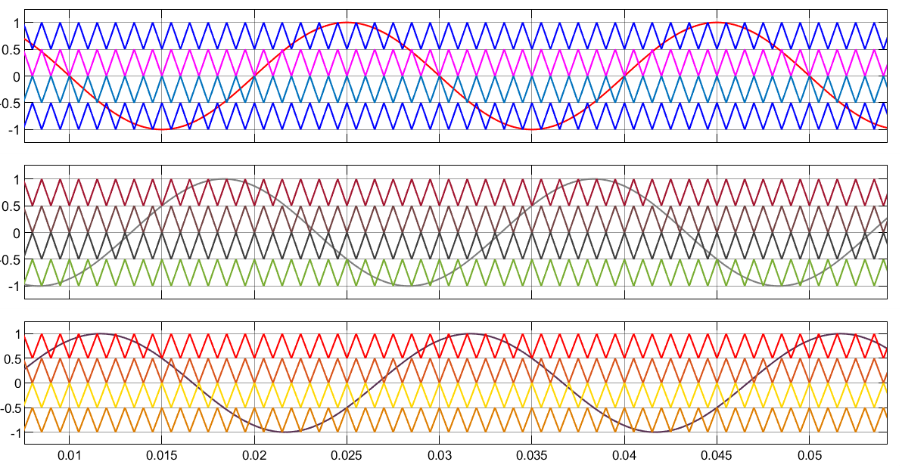

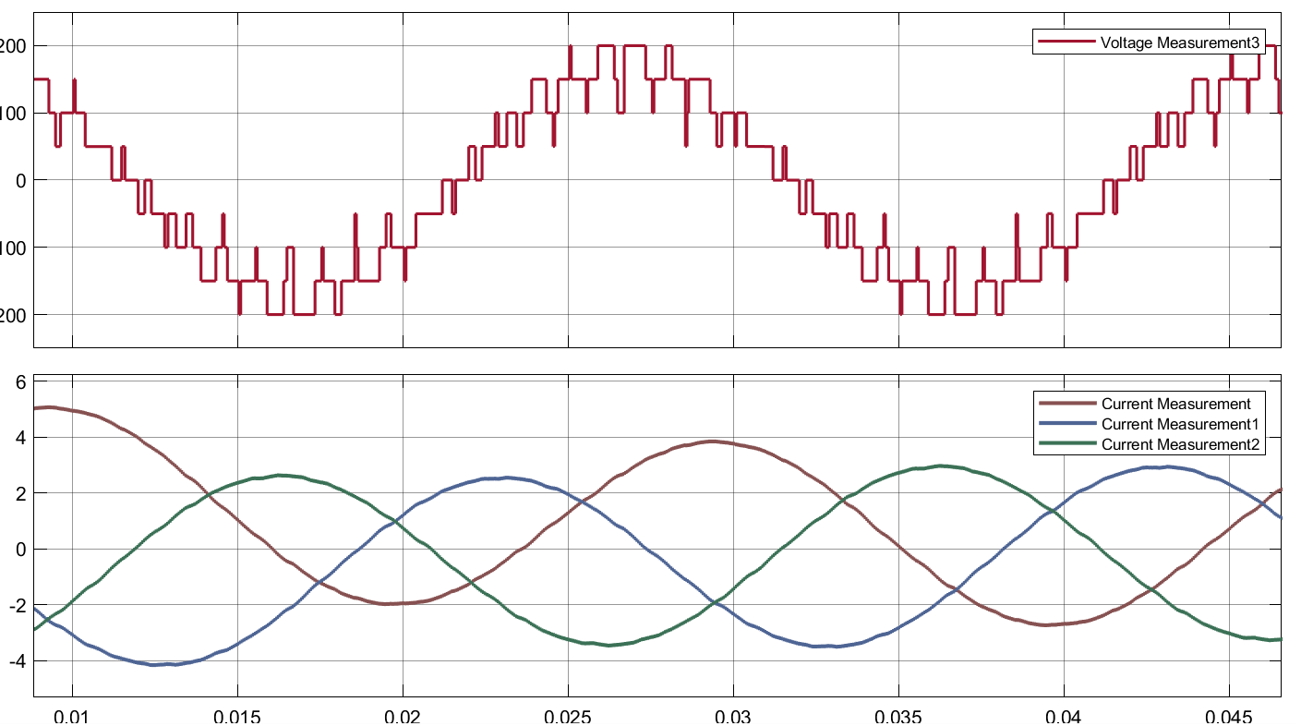

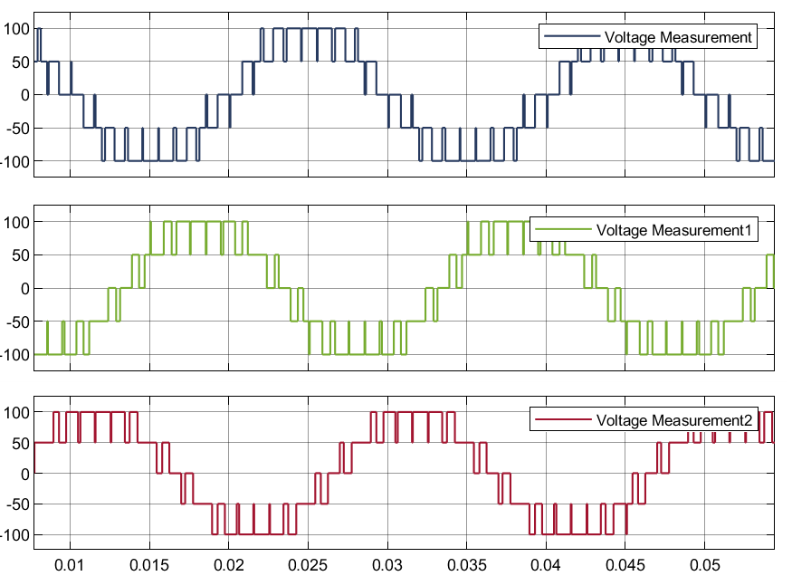

Fig. 6.4: Waveshape of PWM generators (Reference Voltages- Vref_A, Vref_B & Vref_C) ,

Phase Voltages (Van, Vbn & Vcn), Line Voltage (Vab) and Line Current (Ia) of

Cascaded Three Phase H-Bridge Inverter Circuit

* 1. **Discussion & Conclusion**

This experiment thoroughly investigated cascaded single-phase and three-phase H-bridge inverters. RL load open loop was used to design single-phase and three-phase cascaded H-bridge inverter circuits. Four triangular waves of varying amplitudes were used to generate reference voltages. Three single-phase sources of equal amplitude shared a 120° phase shift in a three-phase cascaded inverter circuit. Finally, the experiment was carried out step by step, with each step carried out with honesty and care. As a result, the experiment is said to be a success.